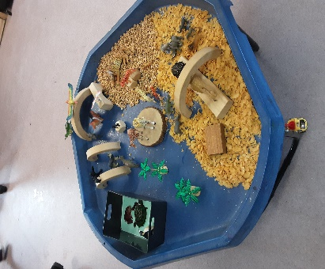
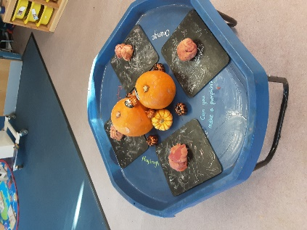
Welcome!
We are
Newton Park
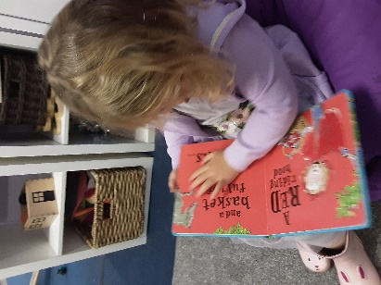
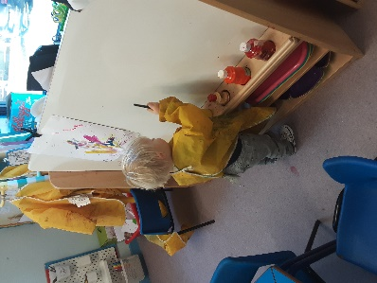
Pre-school

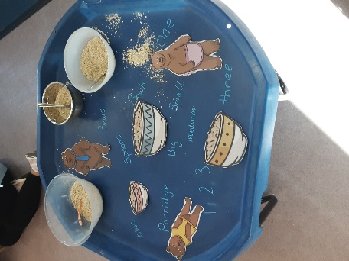
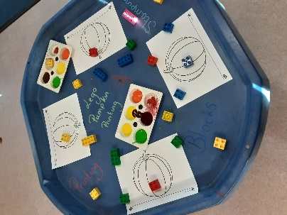
Welcome!
It is with great pleasure that we welcome you and your child/ren to Newton Park Preschool. We are very excited to have you join us!
We will provide your child with the building blocks to build their future. We believe that every child is unique and will grow at his or her own pace. Our staff spend time nurturing children’s strengths and encouraging them to reach new heights.
Our setting follows Anna Ephgrave’s ‘in the moment planning’, the idea with this is that we capture the interests of the child or children in the present moment. Each term your child will become a focus child and we will focus on your child for a period of time and concentrate on their learning and development, following their interests and getting those next steps in that moment. A child’s learning is never limited and one learning experience can produce many outcomes from multiple focus areas.
We use an online system called baby’s days to document your child’s learning journey, here you will find pictures of your child and the day to day activities they are actively participating in, toileting/nappy changing routine, daily diaries for our 2-3 year olds, you can also communicate with your child’s keyworker, and view our policies and procedures, as well as being able to upload your own photos from your child’s homelife.
There are 8 members of staff within the setting, so your child will always be welcomed by a familiar face. There will always be someone available to discuss any matters and please feel free to have a chat with us if you have any concerns.
We follow the Early Years Foundation Stage (EYFS) to track your child’s learning and development, it sets the standards that all early year’s providers must meet to ensure that children learn and develop well and are kept healthy and safe. It promotes teaching and learning to ensure children’s ‘school readiness’ and gives children the broad range of knowledge and skills that provide the right foundation for good future progress through school and life.
We are very excited to support your child in their development and learning in the year ahead, and we look forward in sharing your child’s journey with you!
Meet Our Team
Our team are professional, qualified, experienced carers of children, combining a wealth of practical experience, knowledge and skills with a caring friendly approach. All of our qualified team are paediatric first aiders (with a full 12-hour practical course undertaken every 3 years).
Manager – Claire
Hi, I am the manager here at Newton Park Preschool and have been working within the Early Years sector for over 15 years. I have completed my BA Honours degree in early education. I have 2 children of my own.
Deputy Manager/SENCO –
Chloe
Hi, I am the Deputy Manager and SENCO here at Newton Park Preschool. I have worked within Early Years for many years and have a BTEC Diploma in Early Years Level 3. I have 2 children of my own.

Assistant Deputy – Gemma
Hi, I am the Assistant Deputy here at Newton Park Preschool. I have worked at Newton for nearly 6 years, I have my BTEC Diploma in Early Years Level 3. I am also a student currently in my fourth year studying for my BA Honours in Early Childhood Studies. I have 2 children of my own.
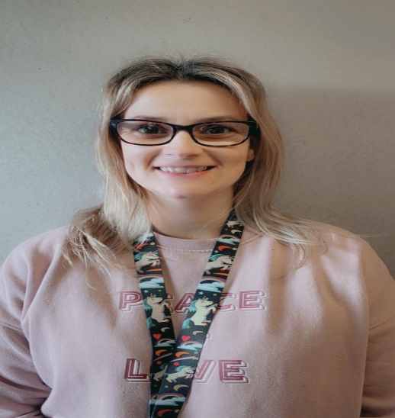
Preschool Assistants
Hi I am Hannah, and have an NVQ Level 3 in childcare. I have 2 children of my own.
Hi I am Sarah, and have an NVQ Level 3 in childcare. I have 2 children of my own.
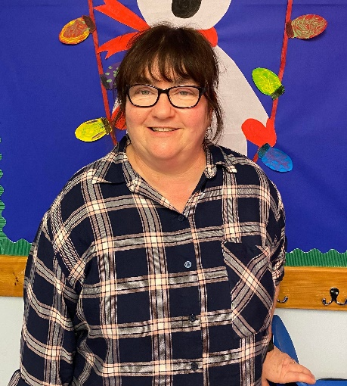
Hi I am Merissa, and have a Cache Level 2 and will be starting level 3 soon. I have 2 children of my own.
Hi I am Cheryl, and have a Level 2 in childcare and will be starting level 3 soon. I have 1 child of my own.

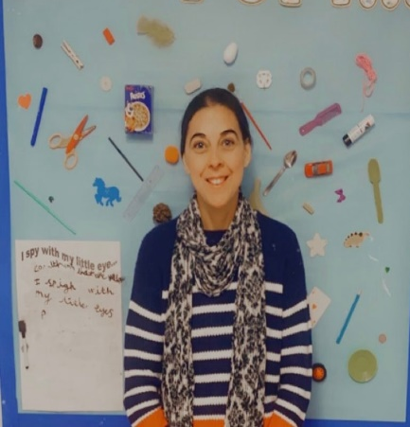
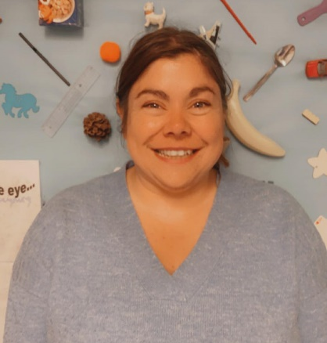
Hi I am Maria, I am a volunteer studying my level 2 in childcare. I have 1 child of my own.
Hi I am Amanda, and I am a student studying for my PGCE. I have 2 children of my own.

Opening Hours
Our daily opening times are 9am till 3pm. We offer 3 sessions a day as follows; we request your child does a minimum of 3 sessions (equivalent to 9 hours):
Full day session: 9am -- 3pm Morning session: 9am -- 12pm Afternoon session: 12pm – 3pm
Cost of sessions: Full day 9 – 3 - £24 half day 9 - 12/ 12 – 3 - £12
We accept government funding for 2-, 3- and 4-year-olds which is currently 15 hours free child care, we have limited spaces for the 30 hours free child care.
We follow the same holidays as Newton Primary School as we are a term time only setting (2022-2023 holidays are set out below)
Autumn Term 2022
Monday 5th September – children return Wednesday 19th October – Break up for half term Monday 31st October – Children return Friday 16th December – End of term
Spring Term 2023
Thursday 5th January – Children return Friday 17th February – Break up for half term Monday 27th February – children return Friday 31st March – End of term 2pm
Summer Term 2023
Monday 17th April – children return Monday 1st May – May Day – school closed Monday 8th May – Coronation of the king - school closed Wednesday 24th May – break up for half term Monday 5th June – Children return Wednesday 19th July – End of term
Registration Form
Child’s name: | D.O.B:
First language: | Additional languages:
Child’s home address:  Postcode: | Telephone no:
Main carer:  Relationship to the child:  Address: (if different from above) | Additional carer:  Relationship to child:  Address: (if different from above)
Email: | Email:
Telephone no: | Telephone no:
Religion: | Religion:
Emergency Contacts
Name: | Name:
Relationship to child: | Relationship to child:
Contact no: | Contact no:
Other settings attending/applied for
Name of school/nursery:

Number of hours/days attending:

Keyworker info:

Medical information
Doctor’s name: | Vaccinations up to date: Yes/no  If no please state the vaccines they have had
Address: | Allergies/special health considerations: i.e., Religion/asthma/eczema/nut allergies
Contact no:

Health visitor:

Contact no:

I/we authorise all medical and surgical treatment, X-ray, laboratory, anaesthesia, and other medical and/or hospital procedures as may be performed or prescribed by the attending doctor and/or paramedics for my child and waive my right to informed consent of treatment. This waiver applies only in the event that neither parent/guardian can be reached in the case of an emergency.

Signature…………………………………………

Print………………………………………………

Date………………………………………………

Trips/outings permission

I give permission for my child to go on small outings/visits. I am aware that some of these outings will take place spontaneously and I may not have been given prior notice. I release Newton Park Pre-school and individuals from liability in case of an accident during activities related to Newton Park preschool, as long as normal safety procedures have been taken.
I am aware of and agree to all Newton Park Pre-School policies and procedures in the policy document (on baby’s days).

Once your child’s place has been secured fees will be charged even if your child is off ill or on holiday.

I agree to my child’s photo being taken and used in their learning journey; group photos will be used universally in all children’s learning journeys (names will never be used).

Signature: | Witness:
Print: | Date:

Sessions
Please use the table below to mark the sessions you require for September. Please note that we have a high volume of new starters in September, so ensure the days you choose are the days you require as it will be very difficult to change the days once the registration has been completed:
 | Monday | Tuesday | Wednesday | Thursday | Friday
Full day 9-3

Mornings 9-12

Afternoons 12-3

Thank You from all at Newton Park Preschool!

